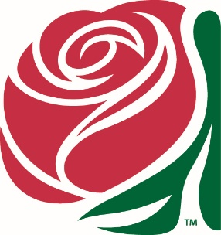
DKG Oregon State Conference April 28 – April 29, 2023
Independence Hotel
Independence, Oregon

The Unique Boutique Annual Report

The Boutique attended the 2022 Conference at the Oregon Gardens as in April, and the Fall Conference in October at Jefferson. We had good sales and positive responses at both events. These were our only sales opportunities, and hope more will be available in the upcoming year. As we move into a more “normal” post-pandemic mode, I am hopeful more events/meetings will be available and will invite the Boutique to participate.
We have received a few out-of-state chapter ribbon name badge orders resulting from contacts made at the International Conference in Portland and via our website, and we are encouraged by this,
Prior to this year’s 2023 State Convention, we have awarded a total of $13,100.00 since 2007.
At the time of this writing we have not received any requests for a Boutique Treasure Stipend for 2023.
Goals for 2023-2024:
- Promote the Boutique Treasure Stipend for first-time attendees.
- Update the Boutique website, https://the-unique-boutique-100675.weeblysite.com/
And promote it more by placing ads in other state’s newsletters.
- Continue to find new merchandise.
- Bring in more members to the committee and delegate more of the jobs.
- Take the Boutique to more events/meetings.

Thank you for your continued support of the Unique Boutique.
Committee:
Janet Walsh, Emerita - Founder
Lynn Hughes, Omega
Pam Westcott-Culp, Beta Beta
Dr. Wendy Hacke, Beta Beta
Catie Thurber-Brown, Chair, Beta Beta

