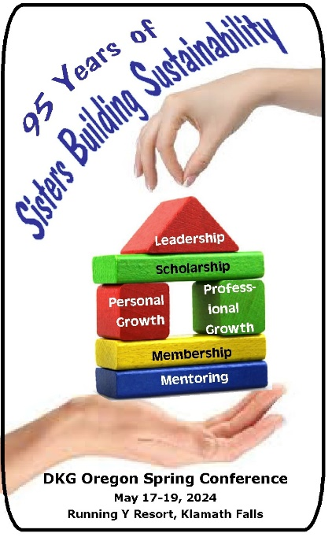
OREGON STATE ORGANIZATION
of DKG INTERNATIONAL
2024 SPRING CONFERENCE
At the Running Y Resort
May 17-19, 2024 in Klamath Falls, Oregon
**************************************
NON-MEMBER REGISTRATION FORM

CONVENTION WEBSITE: https://dkgoregonconvention.weebly.com/
REGISTER: Fill out this form and mail it with your payment to Bonita Fillmore, 1803 Lancaster Ave., Klamath Falls, OR 97601.

____________________ ___ ___________________ _______ __________________________________
Last Name Dr. First Name Middle Initial Name as you want it to appear on your badge.

_______________________________________________________________________________________________
Street Address City State Zip Code
______________________________________ ________________________________
Email Area Code and Phone Number
Photo Release: By your attendance at this event, you are granting your permission to be filmed or photographed and are granting full use of your likeness, name, voice, and words without compensation.

Registration Fee for Friday & Saturday $30.00 $_______
Make checks out to
Oregon State Organization Conference 2024
******
Cancellation requests must be received by May 14th for reimbursement, minus a $10 handling fee.

Late Registration (after May 7, 2024) $35.00 $_______

Friday Morning County & Baldwin Museums Tour $ 8.00 $_______
Friday Morning Trolley Tour add to Museums Tour $10.00 $_______

Saturday Birthday Luncheon Buffet $35.00 $_______
(Must be registered by May 10th to attend
the luncheon for an accurate head count.)
Total Enclosed $________

Dietary requirements:___________________________________________________
Other health concerns: __________________________________________________

PDUs will be awarded for all workshops.
Friday’s afternoon workshops are 90 minutes long and are titled: NAMI (Mental Health) and Conscious Discipline.

Saturday’s one-hour workshops are arranged in 4 sessions not necessarily in this order. Their titles are:
Seeking Leaders; Essential Ingredients for PLC’s; Global Volunteers Service to the Texas Border;
Rain Forests of the Ocean, Sustainability of our Planet; Legislative Updates at the State/National Level;
How to Run an Efficient Meeting; Czech Settlement of Malin; Ment “her” ship: the Bridge to Membership and Leadership; Self-care for Special Education; How a Little ”What If” Turned into a Dream; Creative Writing Done Right; Mentoring New Educators.

Todd Kepple will be speaking on Early Education in the Klamath Basin at Saturday’s Luncheon.

